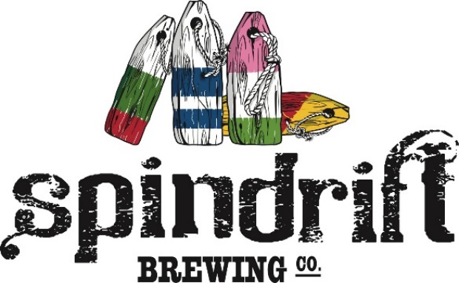
MAY THE BEST
(Wo)MAN-DARINA
WIN! CompETITION.
Spindrift is kicking the homebrew competition season off with the ‘May the Best (Wo)Man-Darina Win!’ competition. This is an Open Style competition.
We’ll even supply the hops!
All entry fees include free access to Spindrift’s stock of 3 new German hop varietals: Mandarina Bavaria (6.0%), Huell Melon (8.6%), and Hallertau Blanc (9.6%).
1st place gets to brew on the Spindrift Pilot System, in-house beer launch, more hops and a ton of Spindrift swag! Also beers…You’ll get beers.
Application Deadline: Friday September 14th.
Beer Deadline: Friday, October 5th. 3pm.
Awards Gala: Saturday, October 13th. Prizes for 1st, 2nd, 3rd.

Bottle Share: Have extra beer? Swap bottles with your competitors at the Gala!

Guidelines: Any BJCP accepted style.
60% total hop mass new German hops.
Minimum 20 IBU.
Minimum 1L packaged product per entry (3x355ml, 2x500ml, etc.)

Entry Fee: $20 fee/entry. Payment can be made with cash at Spindrift
Brewery, or via credit by calling Spindrift @ 902-703-7438.

Hop Access: Submit your recipe to steve.crane@spindriftbrewing.ca
When we receive the entry fee, we’ll weigh out enough hops
for your great beer!
*Send recipe prior to hop pickup to allow for packaging.
**Outside Nova Scotia brewers: Reach out and we’ll find a way to get you the
hops. We’re all in this together and I’m almost out of beer.

Questions/Thoughts/General Excitement?
Reach out to steve.crane@spindriftbrewing.ca. I have all the answers.

