MAY THE BEST(WO)MAN-DARINA WIN!
HOMEBREWING COMPETITION
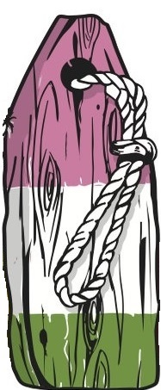
Hops included with registration fee.
Mandarina Bavaria (6.0%)
Huell Melon (8.6%)
Hallertau Blanc (9.6%)

Registration Deadline: September 14th
Beer Deadline: October 5th
Awards Gala: October 13th
Email steve.crane@spindriftbrewing.ca
for registration details.
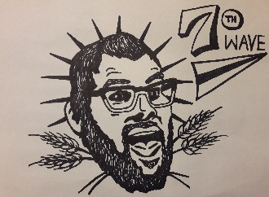
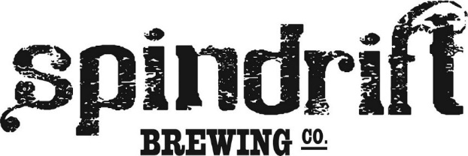
Happy brewing!

